**Project Inception Document (PID)**

# **Secret Santa**

Prepared by:

Mikhail Ajaj - Mathew Whistle -   
Mohamed Ahmed

Date: Jan 26, 2024

# 

# 

# 

**Secret Santa** 1

Project Overview 2

• Purpose 2

• Problem Solving: 2

• Impact: 2

• Feasibility: 3

Team Composition 3

Stockholders 3

Real-World Problems Identification 3

Business Requirements 4

• Participant Engagement (Mikhail Ajaj): 4

• Event Management (Mathew Whistle): 4

• Gift Selection and Purchase (Mohamed Ahmed): 5

o As a participant, I want to be matched with another participant that I would send the gift to. 5

o As a participant, I want insights about my giftee's preferences so that I can select a gift that aligns with their interests. 5

Technology Stack: 5

Database Design: 6

Team Member Responsibilities 7

# Project Software Model (PSM)

* Requiremt Model**:** The app aims to modernize and simplify the organization of Secret Santa events, making it easier for participants to draw names, set gift preferences, and coordinate the exchange anonymously. The Secret Santa app seeks to bring the traditional holiday game into the digital age, allowing users to organize and participate in gift exchanges with ease from their mobile devices.
* Problem Solving: Addresses the challenges in organizing Secret Santa events, such as name drawing, gift preferences communication, and coordination difficulties. It simplifies the process by automating the matching of participants, managing wish lists, and providing a platform for anonymous questions and answers to ensure gifts are personalized and appropriate.
* Impact: Our Secret Santa app is a pioneering service in its domain, offering an unprecedented digital solution to the organization of Secret Santa events. By being the first to market, we anticipate setting the industry standard and capturing a significant user base seeking efficient, tech-driven event management. Our app stands to revolutionize the way participants and organizers experience gift exchanges by streamlining the process, enhancing user engagement, and providing seamless integration with retail partners for a comprehensive gift-giving experience. This innovation not only meets a current market gap but also introduces a new avenue for digital social interaction and e-commerce, potentially altering the landscape of holiday event planning.

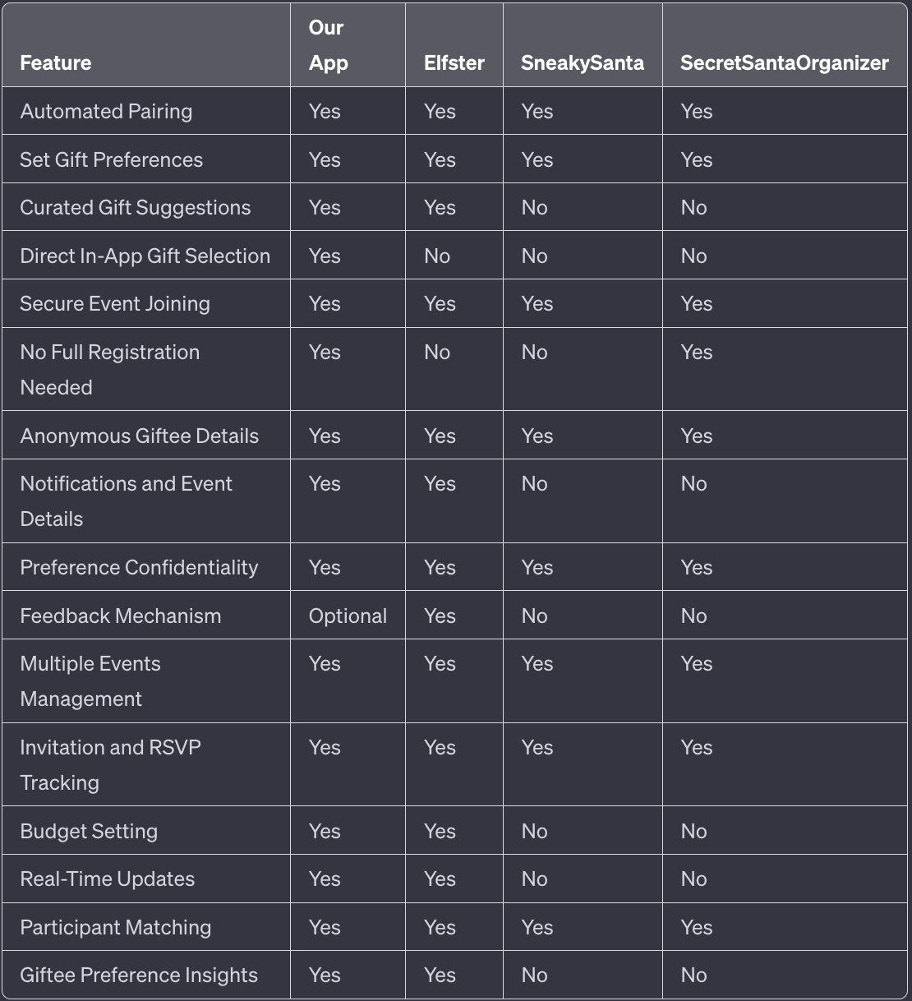

* Feasibility: Our preliminary analysis suggests a project timeline of 2 to 4 months for the development and launch of the Secret Santa app. This estimate includes initial development, testing phases, and a buffer for unforeseen challenges. Financially, the project appears viable within the projected budget, given current resource allocations and anticipated technology costs. Technically, our chosen stack of React Native or Flutter for front-end, .NET for back-end, and MongoDB for the database is well-suited for rapid development and scalability. Our team's expertise aligns with the necessary skill sets for these technologies, supporting a feasible development process. Final feasibility will be confirmed upon completing a detailed market analysis, resource availability confirmation, and a comprehensive risk assessment.

# Team Composition

* **Mikhail Ajaj:** *Project Manager & Lead Developer* - Oversees project development and leads the technical implementation, responsible for setting the project goals, planning, and monitoring the execution, and ensuring that the team adheres to the software development life cycle.
* **Mathew Whistle:** *Scrum Master, UX/UI Designer & Quality Assurance* - Facilitates Scrum ceremonies, assists the team in following Scrum practices, designs the user interface, and ensures app usability and reliability, while also managing the quality assurance process to maintain high standards in software development.
* **Mohamed Ahmed:** *Business Analyst & QA Lead and Risk Analyst* - Analyzes market needs and develops strategies for app promotion and user engagement, ensures the quality of software written, executes tests to verify the correct operations of the application, and identifies potential risks that can impact the quality or development schedule of the project.

# Stockholders

* **Participants (Users):** Individuals who engage in Secret Santa events. They need an efficient platform for event organization and participation.
* **Event Organizers:** People or entities organizing Secret Santa events. They require a tool to manage these events effectively.
* **Gift Retailers (optional):** Businesses that could partner with the app for gift suggestions and purchases.

# Real-World Problems Identification

* **Participant Engagement:** (Mikhail Ajaj - Project Manager & Lead Developer)
  + Problem: Participants may find the traditional Secret Santa process cumbersome and disengaging.
  + Solution: Develop a user-friendly app interface that automates name drawing and gift preferences to enhance engagement.
* **Event Management:** (Mathew Whistle - Scrum Master, UX/UI Designer & QA):
  + Problem: Organizers struggle with coordinating Secret Santa events, especially when managing large groups.
  + Solution: Create robust event management features within the app to streamline organization and communication for event organizers.
* **Gift Selection and Purchase:** (Mohamed Ahmed - Business Analyst & QA Lead and Risk Analyst)
  + Problem: Participants are often unsure what gifts to select and where to purchase them, leading to stress and dissatisfaction.
  + Solution: Integrate a gift suggestion system based on user profiles and preferences, along with a secure in-app purchasing platform.

# Business Requirements

## Participant Engagement (Mikhail Ajaj):

* As a participant, I want the app to automatically pair me with a gift recipient to eliminate manual matching.
* As a participant, I want to be able to set my gift preferences to ensure I receive appropriate gifts.
* As a participant, I want to browse through a curated list of gift suggestions so that I can find suitable gifts easily.
* As a participant, I want to select gifts directly through the app so that the process is convenient and streamlined.
* As a participant, I want to join events using a secure link or barcode and password so that I can ensure I’m joining the correct private event.
* As a participant, I want to confirm my identity without needing to register so that I can participate quickly and easily.
* As a participant, I want to receive details of my giftee anonymously so that I can maintain the surprise element of Secret Santa.
* As a participant, I want to receive notifications and view event details so that I can stay informed and engaged.
* As a participant, I want to ensure my preferences are confidential within the app so that my gift experience remains a surprise.
* As a participant, I want to provide feedback on the event and gift received so that I can contribute to improving future events (OPTIONAL).
* As a participant, I want to explore and receive personalized gift suggestions so that I can find the best gifts for my giftee.

## Event Management (Mathew Whistle):

* As an event organizer, I want to create and manage events within the app so that I can efficiently organize Secret Santa events.
* As an event organizer, I want to send out invitations and track RSVPs so that I can effectively manage participant attendance.
* As an event organizer, I want to specify event details like the number of participants, event location, and budget so that I can tailor each event to specific groups and needs.
* As an event organizer, I want to easily update event details and communicate changes so that I can keep participants informed in real-time.
* As an event organizer, I want to track invitation acceptance and manage event participation.
* As an event organizer, I would like to receive notifications when the process of distributing secret Santas is done.
* User Authentication and Event Creation
* As a host, I want to register on the app so that I can manage my Secret Santa events.
* As a host, I want to create up to 5 different Secret Santa events to organize multiple groups or occasions.
* As a host, I want to specify the number of users, their names, and the location of the gathering for each event ensuring a personalized and organized experience.
* As a host, I have the option to set a budget for the event, making it flexible for different group preferences.

## Gift Selection and Purchase (Mohamed Ahmed):

## As a participant, I want to be matched with another participant that I would send the gift to.

## As a participant, I want insights about my giftee's preferences so that I can select a gift that aligns with their interests.

## Technology Stack:

* **Frontend:**
  + Framework: React Native or Flutter for a cross-platform mobile application, ensuring the app can run on both iOS and Android devices.
  + User Interface: A combination of custom styles and components from a UI library like Material-UI (for React Native) or Flutter's widget library.
* **Backend:**
  + Runtime Environment: AWS cloud service.
  + Framework: .NET framework.
  + APIs: REST API for communication between the frontend and backend.
* **Database:**
  + Primary Database: MongoDB for a flexible NoSQL database that allows for easy changes to the data model.
  + Caching: Redis for caching frequent queries and improving response times. (for better performance)
* **Authentication:**
  + Service: Firebase Authentication or Auth0 for managing user authentication and secure access control.
* **Cloud Services:**
  + Hosting: AWS backend services.
* **Notifications:**
  + Service: Firebase Cloud Messaging (FCM) or a similar service for sending push notifications to the users.
* **Version Control:**
  + System: Git, with GitHub or Bitbucket as remote repositories for source code management.
* **Development Tools:**
* IDE: Visual Studio Code or Android Studio for development.
* Versioning: Semantic Versioning for managing app versions.

## Database Design:

* **Users Table**
  + UserID: Primary key, unique identifier for each user.
  + Username: User's chosen name, unique across the app.
  + Email: User's email address, used for notifications and login.bus
  + PasswordHash: Hashed representation of the user's password for security.
  + DateRegistered: Timestamp of when the user registered on the app.
* **Events Table**
  + EventID: Primary key, unique identifier for each event.
  + HostUserID: Foreign key linked to the Users table.
  + EventName: The name given to the Secret Santa event.
  + Location: The physical or virtual location where the event will take place.
  + DateTime: The date and time when the event is scheduled.
  + Budget: An optional field for the host to suggest a gift budget.
  + Status: Current status of the event (e.g., active, completed, canceled).
* **Participants Table**
  + ParticipantID: Primary key, unique identifier for each participant.
  + EventID: Foreign key linked to the Events table.
  + Name: The participant's full name.
  + HasJoined: Boolean value indicating if the participant has accepted the invitation.
  + GiftPreferences: Text field detailing the participant's gift preferences.
* **Invitations Table**
  + InvitationID: Primary key, unique identifier for each invitation.
  + EventID: Foreign key linked to the Events table.
  + InvitationLink: The unique link to the event's invitation.
  + Password: A password to secure the event and confirm identity upon entry.
  + IsUsed: Boolean value indicating whether the invitation has been used.
* **Gift Preferences Table**
  + PreferenceID: Primary key, unique identifier for each set of preferences.
  + ParticipantID: Foreign key linked to the Participants table.
  + PreferenceType: The category or type of gift preference.
  + PreferenceDetails: Specific details regarding the gift preference.
* **Gift Matches Table**
  + MatchID: Primary key, unique identifier for each gift match.
  + GiverParticipantID: Foreign key linked to the Participants table indicating the giver.
  + ReceiverParticipantID: Foreign key linked to the Participants table indicating the receiver.
  + EventID: Foreign key linked to the Events table.
  + IsGiftSent: Boolean value indicating if the gift has been sent by the giver.

## Team Member Responsibilities

|  |  |
| --- | --- |
| Team Member | Responsibilities |
| Mikhail Ajaj | Project Manager & Lead Developer Oversees project development Leads the technical implementation Responsible for setting project goals Planning and monitoring execution Ensuring adherence to the software development life cycle |
| Mathew Whistle | Scrum Master, UX/UI Designer & Quality Assurance Facilitates Scrum ceremonies Assists team in Scrum practices Designs the user interface Ensures app usability and reliability Manages the quality assurance process |
| Mohamed Ahmed | Business Analyst & QA Lead and Risk Analyst Analyzes market needs Develops strategies for app promotion Ensures software quality Executes tests for application correctness Identifies potential project risks |